**Part 2**

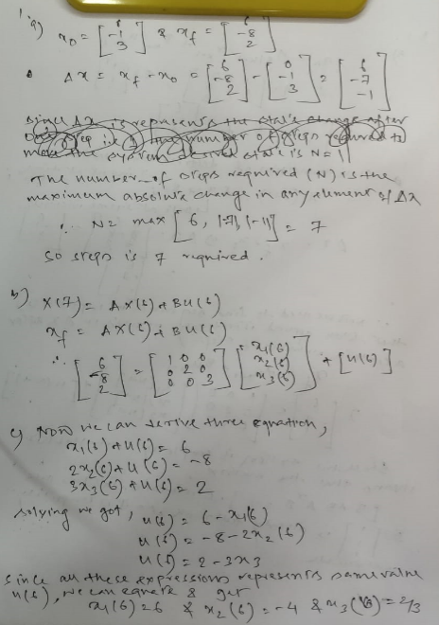

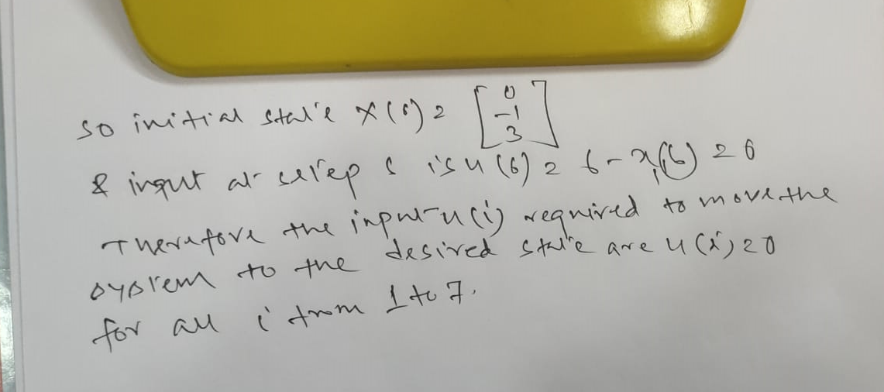

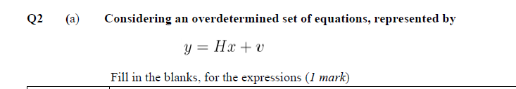

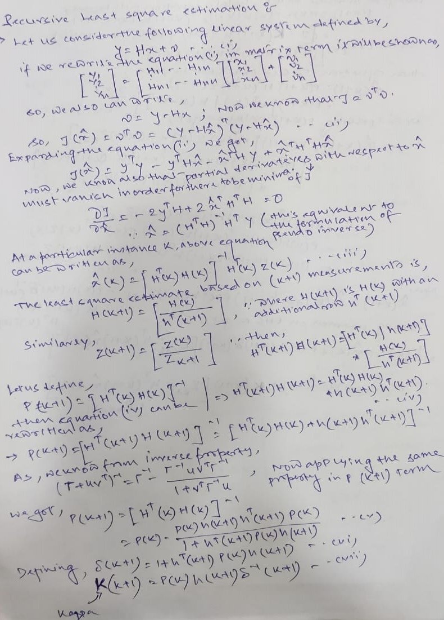

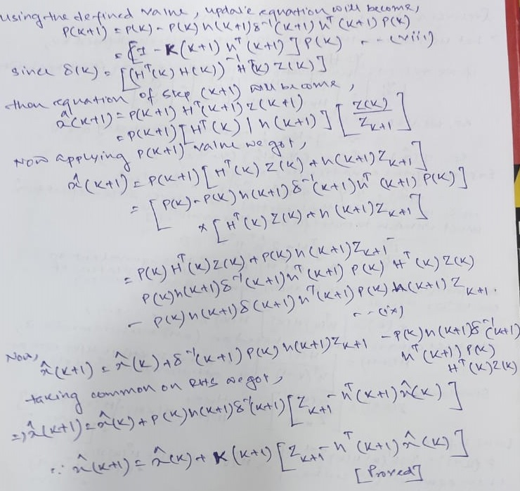

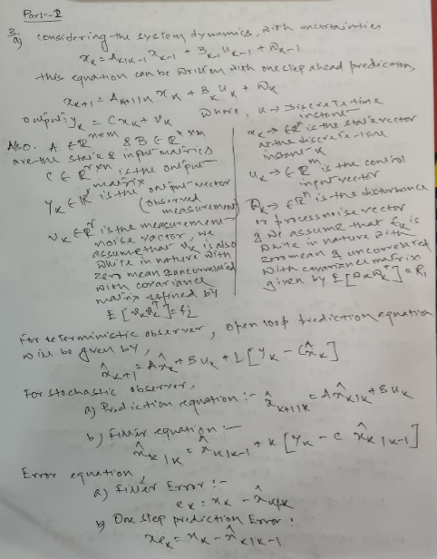

Q.6 7, 8, 9 are done in the jupyter notebook.